National University of Computer and Emerging Sciences, Islamabad
FAST School of Computing


Artificial Intelligence
Date of Submission
8th May 2025
Lecturer: Ms. Azka Atiq

XONIX GAME
Overview of the Project:
Xonix game is a 2D style game developed using SFML in C++. The basic game was already designed and our task was to make it more better and implement some new and interactive features which included single and two player modes, difficulty level, enemy patterns, scoring and much more.
Features Implemented:
The features on which both of us worked are :
1. Basic Features
● Single and Two Player Modes
● Start Menu
● End Menu
2. Difficulty & Enemy Count
● Circular movement
● Zig-Zag movement
3. Movement Counter
4. Enemy Speed & Movement
5. Scoring & Reward System
6. Scoreboard
7. Two Player Mode Rules
Game development Approach:
1.Understanding:
As soon as the project came we both first understood the features that were already implemented and also the features we have to implement.
2.Planning phase:
After understanding the whole game including what features we have to implement we planned how to complete the project in the given timeline and also divided work among each other. Also we both discussed about the layout of our game.
3.Development:
As we started doing our respective part whenever any of us find difficulty in implementing any logic we helped each other in that too.
Task Distribution:
Laiba – basic features, difficulty & enemy count, scoreboard, report
Anamta –Enemy speed and movement, movement counter, workflow diagram
On Two player mode and Scoring and reward system we worked together.
Implementation of Features:
As we have to display menu on the board so for that we studied a little bit of SFML in order to get idea on how we can do that remaining things in this portion were simple and we also helped eachother in things one member is stucking. In some things SFML is implementing so we also gone through that library not deeply but we just took an overview of it.
Game Working:
As the game starts the user first sees a menu where he or she can select the mode he or she wants to play in, also he or she can select the difficulty level the user can also see the scoreboard. The user first have to select the mode he or she wants to play in one player or two player after selecting that the user selects the difficulty level easy, hard ,medium or continuous mode each of these have their own features. After that the game starts the player has to construct tiles while staying away from the enemy according to which the score gets incremented the player gets out whenever the enemy touches the path player is constructing or the player takes u turn in these cases the player live is over. And the game board shows the score of the player and much more. Below is the more detailed working of the game.
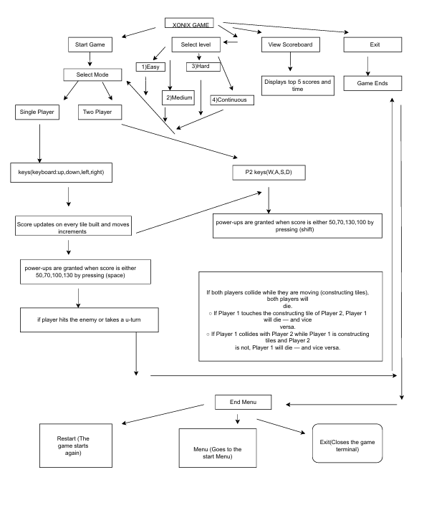
WorkFlow Diagram:
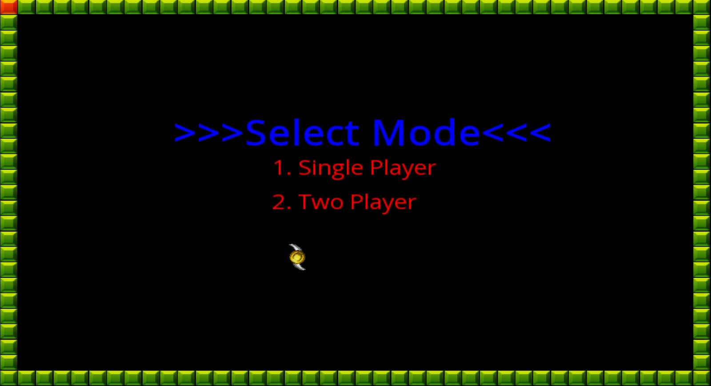
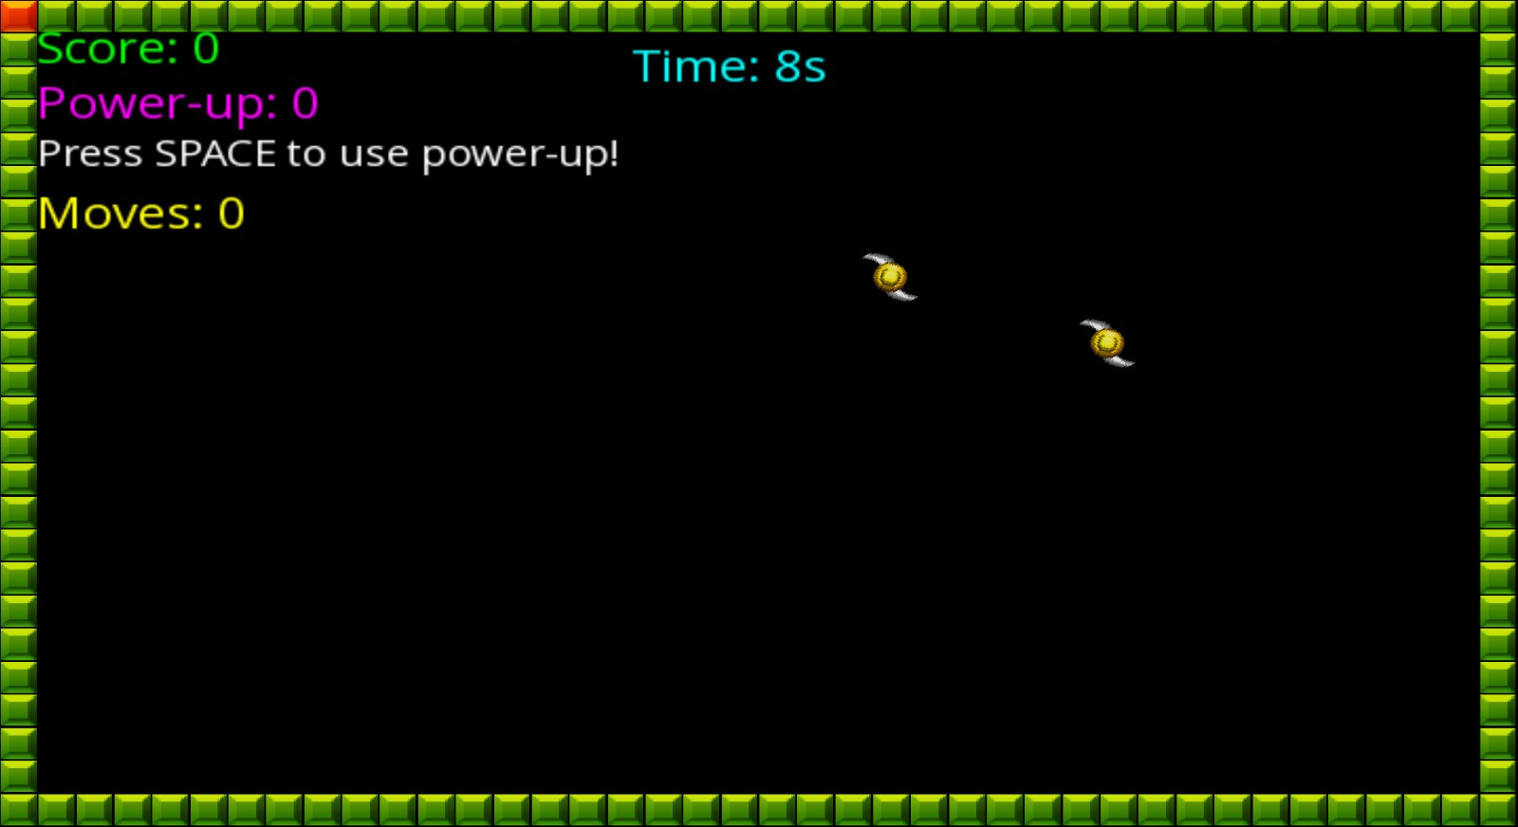
Visuals of the game: 